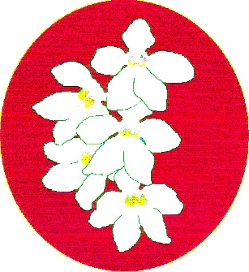
BATEMANS BAY ORCHID AND FOLIAGE SOCIETY INC.
PO Box 3334 Batehaven
NSW 2536
Newsletter – June 2023
President: Anne-Marie Collins 0427 885 186
Vice President: Dylan Morrissey
Secretary: Margaret Turner 0409 442 704
Treasurer: Leanda O’Connor 0475 848 832
Committee: Pam Mason, Heather Dennison, Sabrina Wu
Web page: www.batemansbayofs.weebly.com
Email: bbayofs@gmail.com
Facebook page: http://www.facebook.com/bbofs/

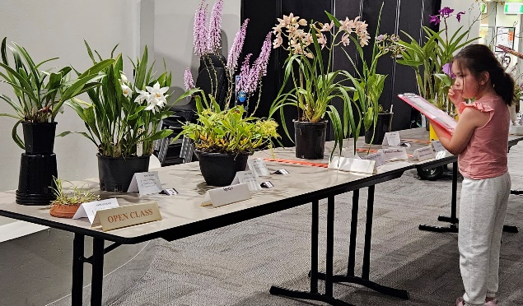
We start them young in our club.
President’s Report
Hello members,
Very sad news of Megan’s passing. A lovely lady and great helper, in our club, at meetings and shows. She even came to one of the shows, to help on the sales table, last year, after leaving hospital the day before. Her plants were well looked after and she had some lovely Foliage plants and orchids. Megan will be missed, for many reasons, including her willingness to help with posy making.
Steve, the brom man, was very educational at our May meeting. The visit to his business on the Saturday saw seven of our members and guests learn more. We were amazed at how so many plants could fit into such a small area. Also we bought a few to take home as mementos of our visit.
Next meeting, we have Dylan talking on preparing plants for our up coming shows. I am looking forward to this, as his experience is quite extensive.
Coffee club at J.J.s, was enjoyable (3rd Thursday of the month). Come along, all topics are discussed, not just orchids. The oreo cheesecake is divine.
Hoping to seeing you all, at the June meeting. Keep warm.
Cheers Anne-Marie
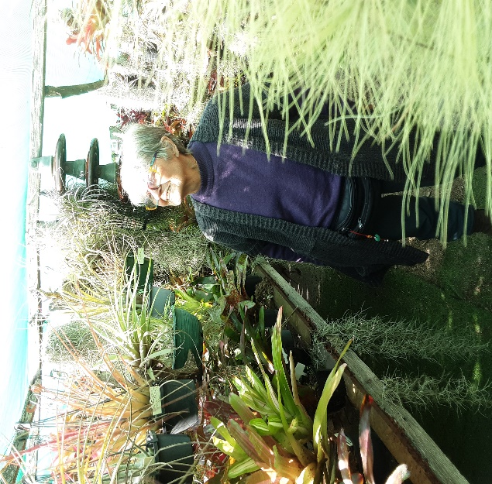
Liz enjoying the sunshine while admiring the Bromeliads at Steve’s

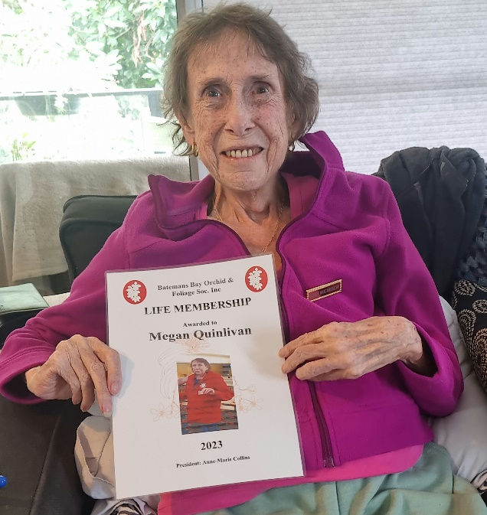
Megan with her Life membership.
Vale Megan Quinlivan.
It is with much sadness that we acknowledge Meg’s recent passing. She has been an active member of BBOFS since late 2012 doing a number of roles within the committee.
She was member who tended not to be seen, but without the work she did behind the scenes, some activities would not have run so smoothly.
While we didn’t see too many orchids that she grew, we did see regular benching of ferns and foliage.
Meg had requested a private service to mark her passing with just her family.
Our sympathies are extended to Jim and her family.
From the Committee.
NEEDED: bases of the 1.25L soft drink bottles for posies please. These can be given to Margaret, Leanda or Anne-Marie. These are used for making posies for the shows. This activity, thanks to a small group is a good money maker for us. We need about one hundred of these for each show, so please help us by keeping the bases from the ones you empty.
There will be copies of the Show Schedule and plant labels available at both the June and July general meetings as well as these being sent out with the July newsletter.
If you have a perpetual trophy for any show, could you please return it to Margaret either at a meeting or by contacting her to arrange pickup or drop off. Thanks.
Margaret will organise bags for plants at the show after this was raised at the general meeting.
My apologies for not sending out the AGM minutes before now, but they will be sent with this newsletter.
All the motions voted on at the AGM have been actioned except the renaming of the Native Show, which will happen when we are doing the preparation for that show.
If members would like to donate something to the raffle table for the shows, it would be appreciated. We will ask Bunnings as they normally help us out, but a range of goods is always appreciated.
The South and West Regional show is the long weekend in October at Cobargo. At previous shows we have done a display of our orchids in line with the identified theme. This year the theme is “” Australia in Poetry and Song””. For BBOFS to put on a display, we need our members to commit to us that they will provide some flowering pots. Previously, this has been a challenge. We need your support to be able to put on a display. The displays are a big part of the show. Benching/set up for the show is Friday 29th September and judging that evening. Open to the public Saturday 30th September and Sunday 1st October.
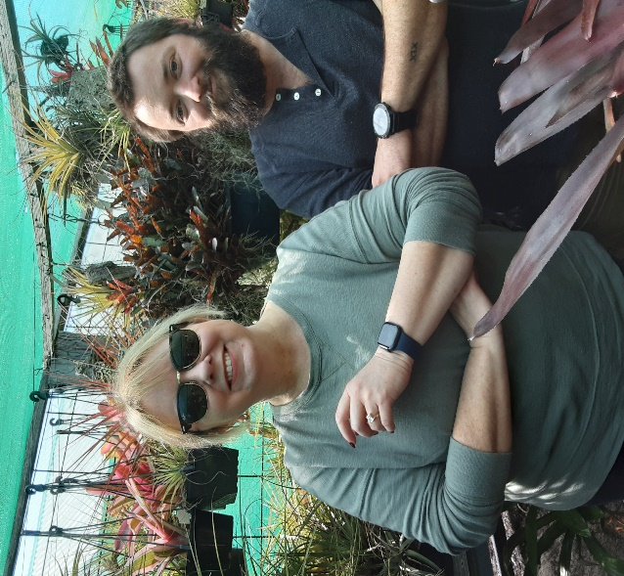
Pam & Dylan enjoying the Broms
In your Orchid House
This cold weather is an indicator that winter is well and truly on its way. But the lack of rain is also good, however, that does mean that we need to keep an eye on the condition of the pots and not to let them dry out too much. Some genre still need regular watering as they develop their spikes, so we can enjoy the pretty flowers over the next six (6) months.
Unfortunately, the cold weather doesn’t deter the bugs, so keep an eye out them, especially around new growths and flower spikes.

Floral Art Group.
Mothers’ Day was the theme from the last get together and as you can see from these photos, some lovely displays were produced. The next Floral Art group meeting is Monday 22nd May. They will be exploring diagonal and two tier displays.

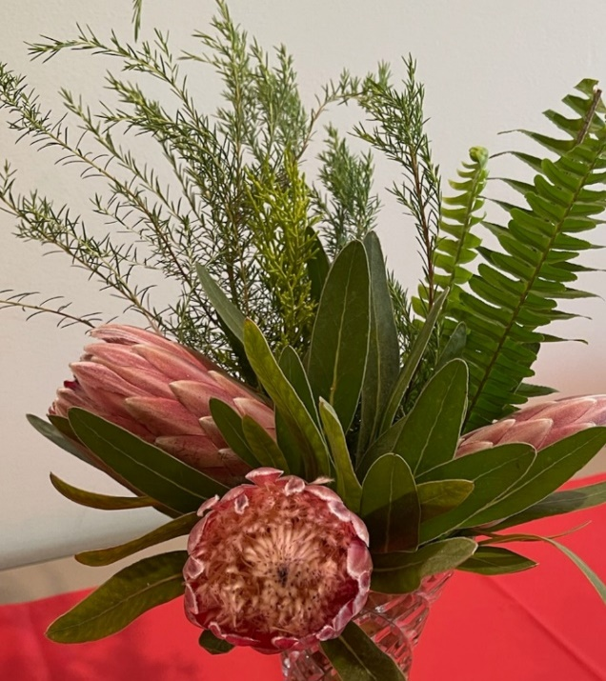

Diary Dates
2023 Show dates
July
1 2 MUOS Winter
7 8 EOC Winter
14 15 & 16 BBOFS Winter
August
11 12 13 Sapphire Coast Winter
September
1 2 3 BBOFS Spring
9 10 MUOS Spring
16 17 EOC Spring
October
20 21 22 BBOFS Native
27 28 Sapphire Coast Summer

BBOFS Activity Dates
August 12th Walk in Botanic Gardens to see Native orchids with Dylan; time TBC
October 14th Tri club BBQ and walk in cemetary looking for Native orchids at Nelligen time TBC
Regional Activities dates
September/October
30 1 South and West Regional Show and Conference Cobargo. (see committee notes please)
Benching
Open Section
Species: Dylan Morrissey
Cymbidium > 90mm:
Cymbidium 60 - 90mm: Liz Cleaver
Cymbidium < 60mm:
Aust Native Orchid:
Laeliinae >70mm: Margaret Turner
Laeliinae <70mm: Margaret Turner
Paphiopedilum:
Vandaceous:
Pleurothallidinae:
Oncidiinae Alliance: Liz Cleaver
Seedling:
Miscellaneous: Liz Cleaver
Fern:
Foliage: Leanda O’Connor

Plant of the Night - Open
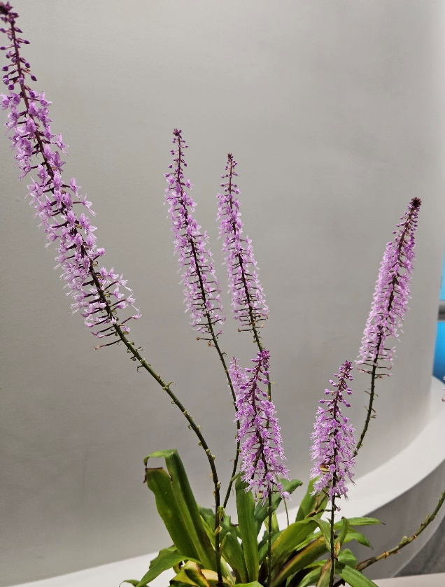
Stenoglottis Longifloia Dlyan Morrissey
Floral Art
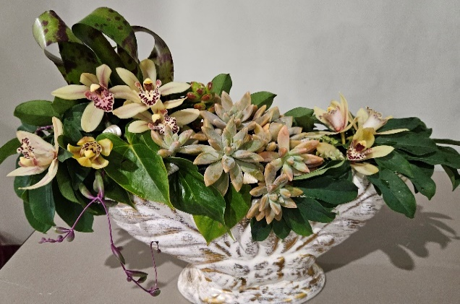
Pam Mason

Novice Section
Species:
Cymbidium > 90mm:
Cymbidium 60 - 90mm:
Cymbidium < 60mm:
Aust Native Orchid:
Laeliinae >70mm:
Laeliinae <70mm:
Paphiopedilum:
Vandaceous:
Pleurothallidinae:
Oncidiinae Alliance:
Seedling:
Miscellaneous:
Fern: Ken Covington
Foliage:

Plant of the Night – Novice –
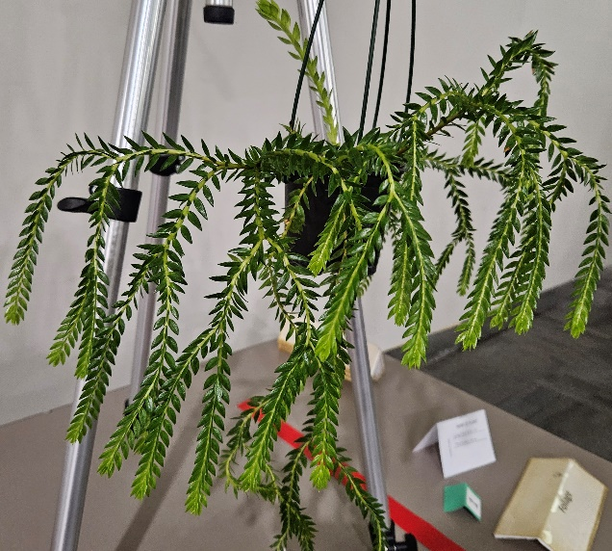
Tassel Fern Ken Covington

BATEMANS BAY ORCHID AND FOLIAGE SOCIETY INC.
DRAFT MINUTES OF THE GENERAL MEETING HELD Soldiers Club Beach Road, Batemans Bay.
Monday 1st May 2023
PRESENT: Members: 14 Apologies: 1 Visitors: 2
President Anne-Marie opened the meeting at 7.30pm thanking all for coming
MINUTES: accept the Minutes of the last General Meeting held on Monday 3rd April at the Soldiers Club Beach Road Batemans Bay having been circulated as a true copy.
Moved: Margaret Turner Seconded: Ron Boyd Carried
BUSINESS ARISING: included in the General Business.
CORRESPONDENCE:
- Magazines: Orchids Australia,
- Newsletters from Wagga Wagga, Sapphire Coast, Milton/Ulladulla, Canberra, N.S.WOS, Shoalhaven; EOC; Blue Mountains & Penrith Districts OS
- Bank statement
- Applications from 2 new members
Out
- BBOFS Newsletters
- BBOFS newsletters to other orchid clubs
- Badge order for new members
Moved: Margaret Turner Seconded: Dylan Morrissey Carried
2. TREASURER’S REPORT:
Treasurer Leanda presented:- Opening balance $8762.96; Income $340.20; Expenditure $34.00; Unpresented cheques $114.04; Floats/cash tin remain the same, plus IBD total fiscal $31,155.12. Vouchers available for raffles.
Moved: Leanda O’Connor Seconded: Robert Fish Carried
Leanda requested permission to pay outstanding accounts.
Moved: Leanda O’Connor Seconded: Robert Fish Carried
3. GUEST SPEAKER: Steve Morgan – the Bromeliad man
Steve has been growing bromeliads for many years and has an amazing collection growing in his back yard. He brought in a range of his plants to talk to during this presentation. Steve stated there were about 400 different varieties of bromeliads available.
At this time of year, most of the flowering has finished as it is getting colder. He grows his plants under shade cloth with extra protection during winter. Bromeliads, like most plants have some that are heat lovers and some that prefer the colder areas. Plants that prefer the cold will yellow if receive full sun, so position is important for them, like most plants including orchids. Plants that have variegated leaves are very particular to have a position that suit their growth habit, as they tend to be slower growers.
Most bromeliads take nutrients in through their leaves that is they are leaf feeders. They do not require a lot of fertilizer. Steve uses Thrive – Flower and Fruit and dilutes about two (2) teaspoons to 16 litres of water – in other words “weakly weekly””. Most of the bromeliad leaves have spikes. Some leaves stand upright and other clump. They flower from the centre and with one variety – Neo the leaves flatten out which enables the flowers to be seen more readily.
Some bromeliads will grow on trees, using their roots to cling to the tree. Steve uses an open potting mix to grow his plants in, including perlite, large bark, charcoal and pine bark. Some can be mounted. If planning on mounting, Steve uses liquid nails original to attach the plant to the board.
Pests he mentioned included caterpillars which just love the leaves, grasshoppers, mice and mealy bugs. Steve said it was really important not to use an insecticide that contains copper as that will kill the plants. He also said to not use any treated pine products around them as that will also kill the plants.
Watering depended on the type of plant. Some he may only water 3 times a year, but mostly depends on the plant and the weather. In winter, he will empty the water from the centre of the plant, so it doesn’t get too cold. Coldest in Batemans Bay last two weeks of July and first two weeks of August. Steve gets frosts where he lives, so takes extra care during that month.
If taking “pups”” Christmas time is the best time to do it. March is too late. The pups should be about half the size of the mother plant, otherwise they may not reach their full potential. That then means that any plant grown on from that pup will also not realise what it should and thus impacts on the quality of the plants going forward.
Anne-Marie thanked Steve for coming and his interesting presentation and reminded members of the visit to Steve’s home on Saturday. Steve will have plants for sale at that time.
4. GENERAL BUSINESS:
Presentation of certificates: name badge to Everley Morrissey; PON certificates to Ken and Pam.
- Next General Meeting; Dylan – preparing plants for showing at meetings and shows
- Visit to Steve’s next Saturday – 12 Caitlin Cres Broulee at 10.30.
- Megan’s life membership was presented to her by Anne-Marie, Leanda and Margaret on 23rd April. She was very pleased to receive it and thanked everyone for the recognition.
- Bus trip – no further information available and no members had contacted Anne-Marie about going on the bus. Anne-Marie had not heard about costings either. After some discussion, it was agreed the BBOFS would not be supporting the trip with the $200.
- Square – as the costs associated with the purchase and use of Square Reader have been decreased for Not for Profit organisations and currently we can purchase the devise for a much reduced cost and we have access to a smart phone that can be connected to the devise, the decision was made to go ahead and purchase one. Margaret to action purchase and set up.
- Robert Fish asked if the committee had considered purchasing bags for use at the shows. As this had not been done, it will be put on the May committee meeting agenda.
- Robert also asked if all the motions discussed at the AGM had been actioned. Anne-Marie felt that they had. Robert cannot find his copy of the AGM minutes. Margaret undertook to identify when they were sent out and to send him another copy.
- Anne-Marie reminded members of the “Coffee Club” which is a social gathering of members to enjoy some social time together. It is held at JJ’s on the Marina on the 3rd Thursday of the month from 2 to 4pm.
5. RAFFLES: Margaret Cameron, Liz x 2; Ken; Dylan; Brian x 2; Evelyn; Heather; Leanda; Pam; Anne-Marie.
LUCKY DOOR PRIZE: Morrissey family
Plant of the Meeting winners were announced. Results in the Newsletter.
Meeting closed 9.15pm
The next meeting will be on Monday 5th June Benching from 6.30pm, judging from 7pm and meeting at 7.30pm.
At Soldiers Club; Batemans Bay
Secretary Margaret Turner
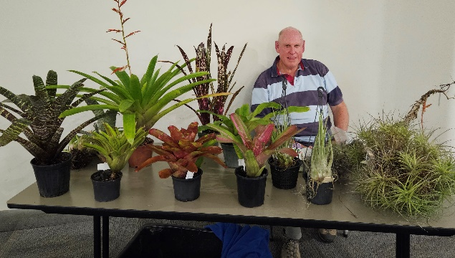
Steve with the plants he brought in to talk about.
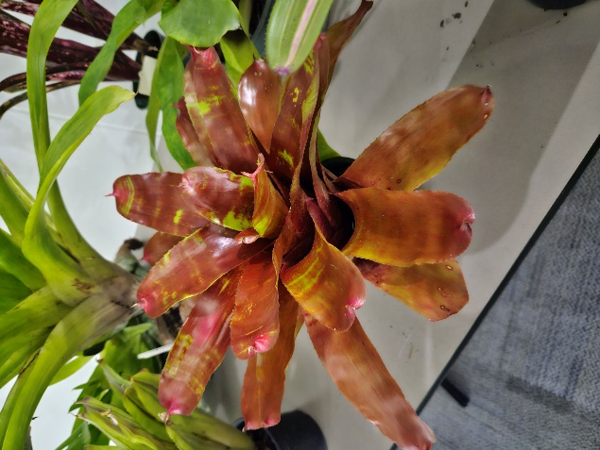
Variegated leaves

Soldiers Club Beach Road
Major sponsor of our club.
Bunnings of Bateman’s Bay
Sponsoring our Club through its BBQ’s and other activities.

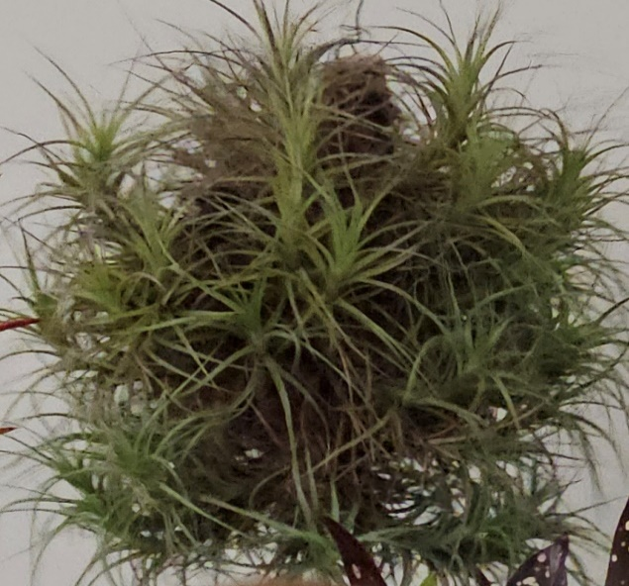
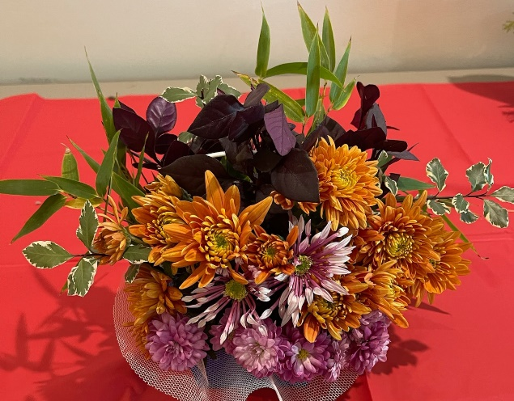
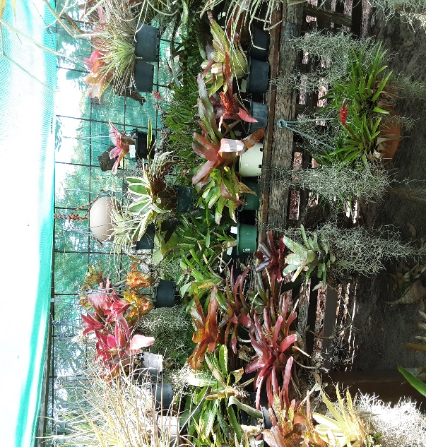

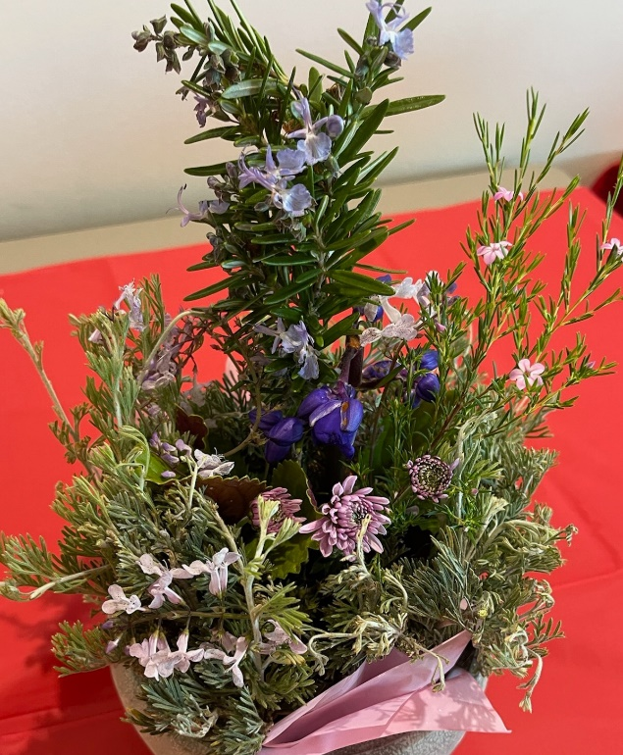
Apia Insurance
Specialising in Insurance for the over 50s

Supporting your community

Supporting our club by sponsoring our shows.
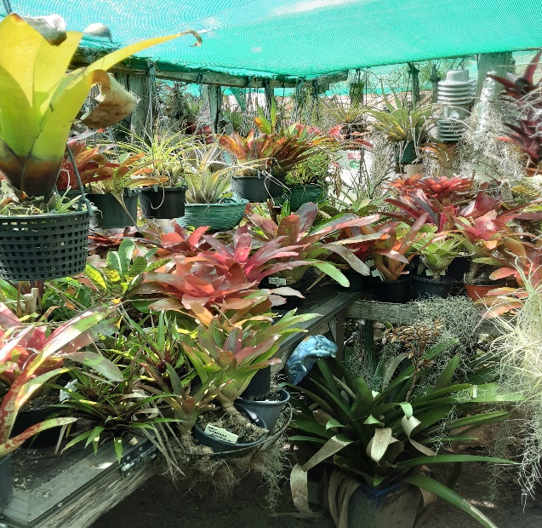

The cultural information offered in this newsletter is intended as a guide only. Bateman’s Bay
Orchid & Foliage Soc. Inc. cannot be held responsible for any loss or damage that may
occur to plants as a result of using this information.

